**Hello Team!Consider the below two tables**:

**Ques.1. Write a SQL query to fetch the count of employees working in project 'P1'.** 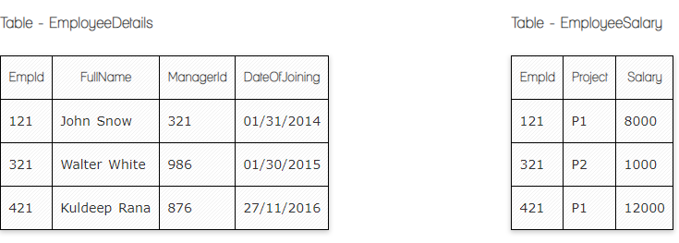

**Your Answer:**

**Select count(EmpId) FROM EmployeeSalary**

**Where Project = ‘P1’**

**Ques.2. Write a SQL query to fetch employee names having salary greater than or equal to 5000 and less than or equal 10000.**

**Your Answer:**

**Select Fullname from EmployeeDetails where id in(Select EmpId from EmployeeSalary Where (Salary>=5000 And Salary <=10000))**

**Ques.3. Write a query to fetch employee names and salary records. Return employee details even if the salary record is not present for the employee.**

**Your Answer:**

**Select Fullname, Salary from EmployeeDetails as n left join EmployeeSalary as s**

**On n.Id = s.EmpId**

**Ques.4. Write a SQL query to fetch all the Employees details from EmployeeDetails table who joined in Year 2016.**

**Your Answer:**

**Select * from EmployeeDetails**

**Where DateOfJoinig LIKE ‘%2016%’**

**Ques.5. Write a SQL query to insert new record to the EmployeeDetails table with any data.**

**Your Answer:**

**INSERT INTO EmployeeDetails(Fullname, ManagerId, DateOfJoining)**

**VALUES (‘Kristine’, ‘321’, ‘22/07/2021’)**

**Ques.6. Write a SQL query to update EmployeeSalary table with setting Salary to 2000 for Project P2.**

**Your Answer:**

**Update EmployeeSalary**

**SET Salary = ‘2000’**

**Where Project = ‘P2’**



**Ques.7. Write a SQL query to right join both tables and draw the results.**

**Your Answer:**

**Select * from EmployeeDetails right join EmployeeSalary**

**On EmployeeDetails.EmpId = EmployeeSalary.EmpId**

|  |  |  |  |  |  |  |
| --- | --- | --- | --- | --- | --- | --- |
| **EmpId** | **FullName** | **ManagerId** | **DateOfJoining** | **EmpId** | **Project** | **Salary** |
| **121** | **John Snow** | **321** | **01/31/2014** | **121** | **P1** | **8000** |
| **321** | **Walter White** | **986** | **01/30/2015** | **321** | **P2** | **1000** |
| **421** | **Kuldeep Rana** | **876** | **27/11/2016** | **421** | **P1** | **12000** |

**Now take these two tables:**

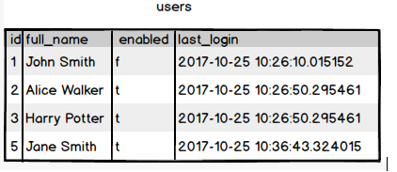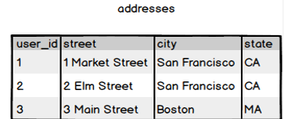

**Ques.8. Write a SQL query to fetch all users full_name from San Francisco.**

**Your Answer:**

**Select full_name from users where id in (Select user_id from addresses where city = ‘San Francisco’)**

**Ques.9. Write a SQL query to fetch all users full_name, last_login who are enabled**

**Your Answer:**

**Select full_name, last_login from users**

**where enabled = ’t’**

**Ques.10. Write a SQL query to fetch all users full_name who are not from 3 Main street**

**Your Answer:**

**Select full_name from users where id NOT in (Select user_id from addresses where street = ‘3 Main street’)**

**Ques.11. Write a SQL query to fetch all users full_name who are from 3 Main street or San Francisco**

**Your Answer:**

**Select full_name from users where id in (Select user_id from addresses where ( street = ‘3 Main street’ OR City = ‘San Francisco’))**

**Ques.12. Write a SQL query to fetch user full_name who is equal to user_id from Boston (find user_id value in sub_query)**

**Your Answer:**

**Select full_name from users where id = (Select user_id from addresses where**

**City = ‘Boston’))**